## Decision Tree

* A decision tree is a flowchart-like tree structure where each internal node denotes the feature, branches denote the rules and the leaf nodes denote the result of the algorithm.
* Decision tree is a hierarchical data structure that represents data through a divide and conquer strategy.
* A decision tree is a simple model for supervised classification. It is used for classifying a single discrete target feature.

**What does a Decision Tree do?**

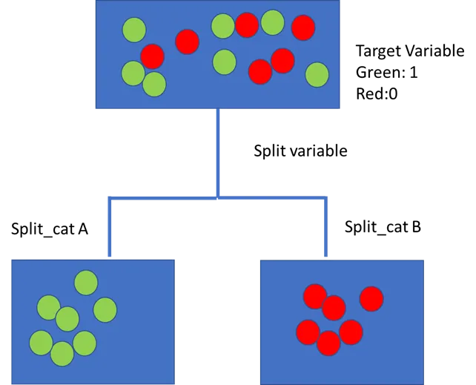

**Decision Tree Look like:**

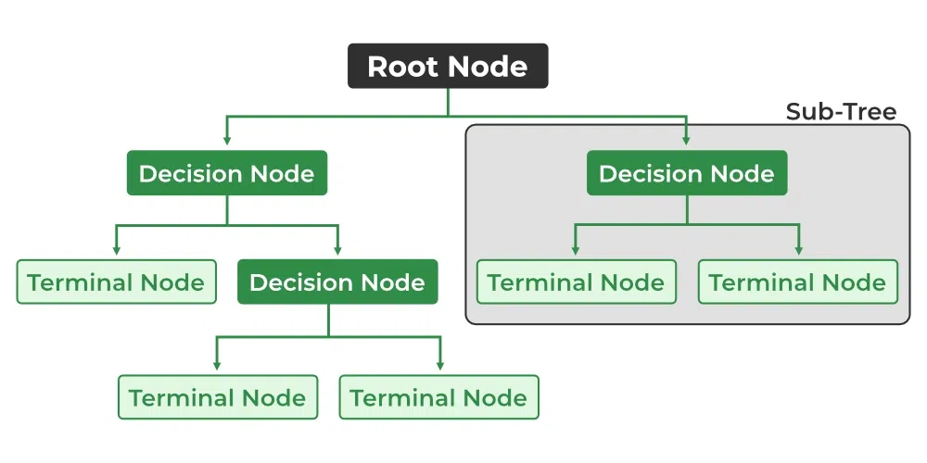

X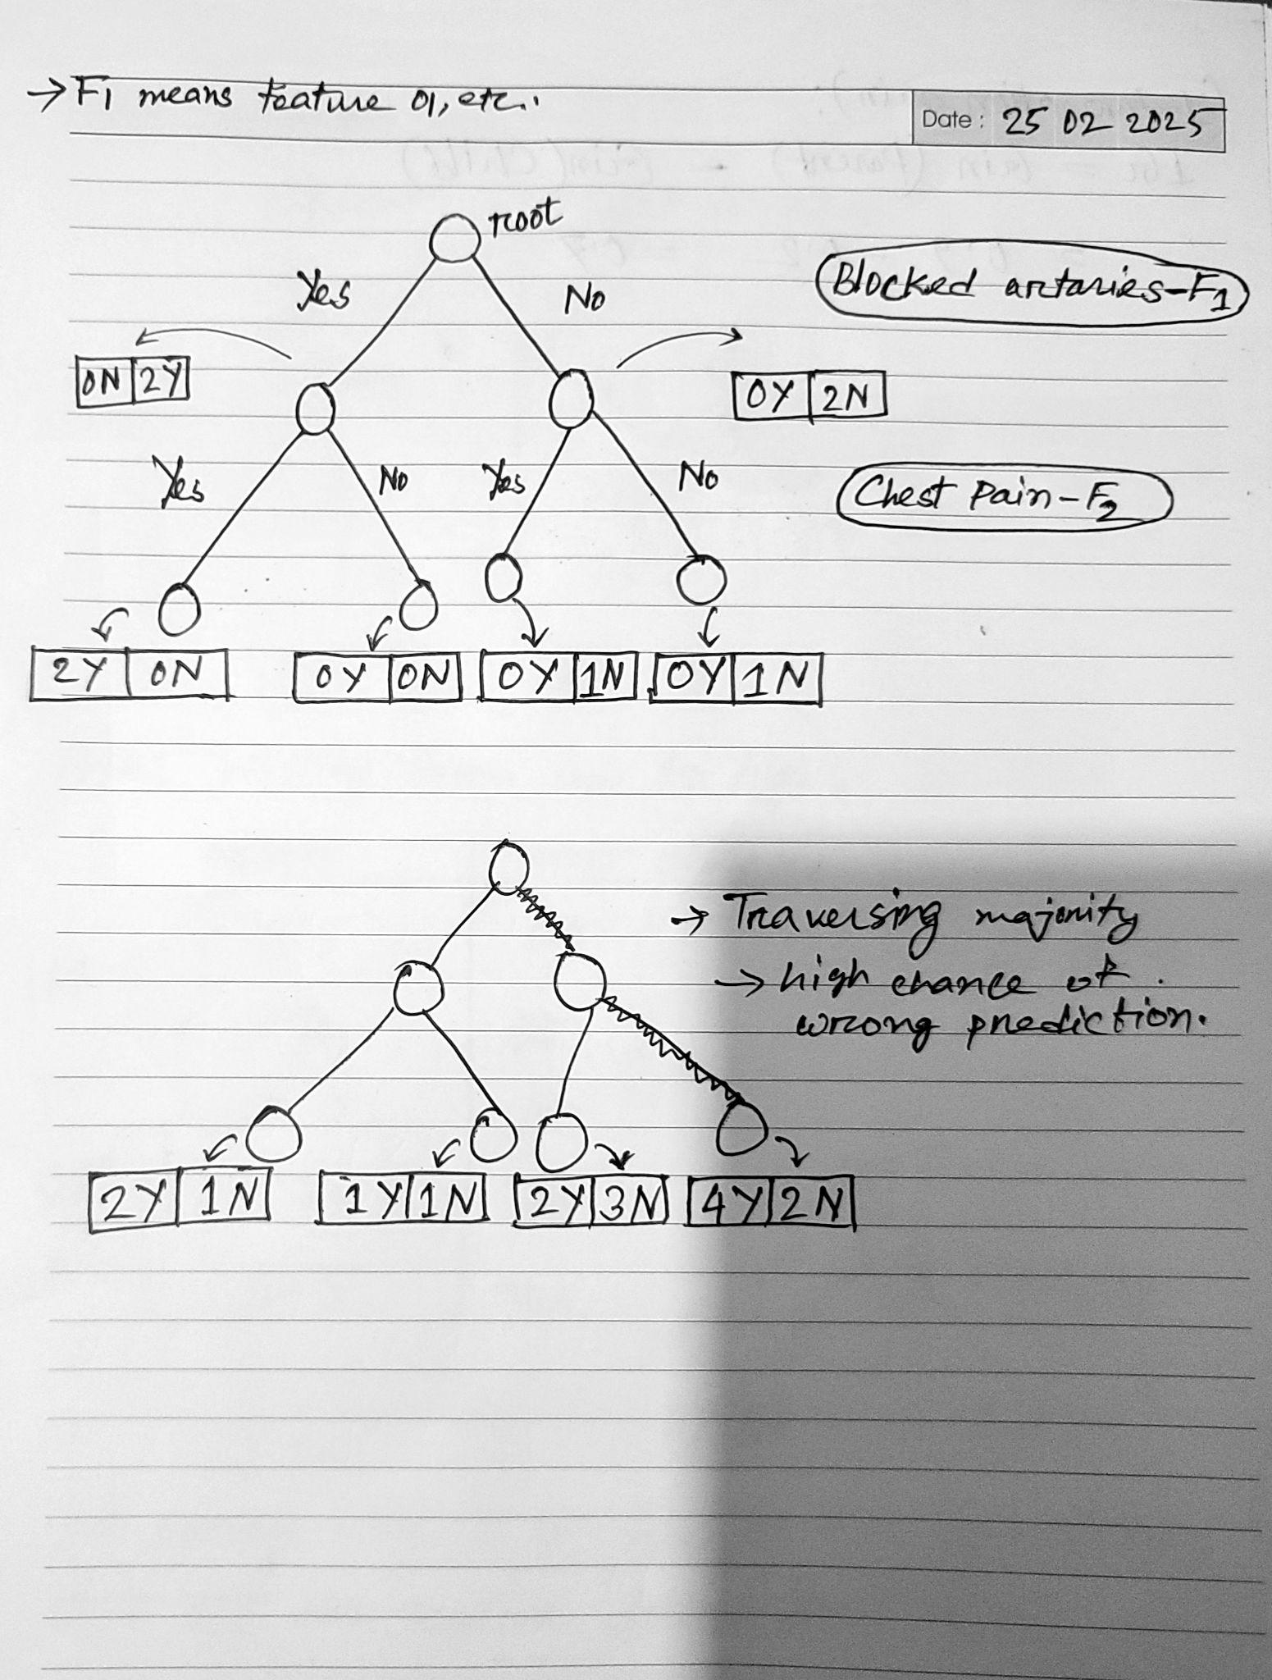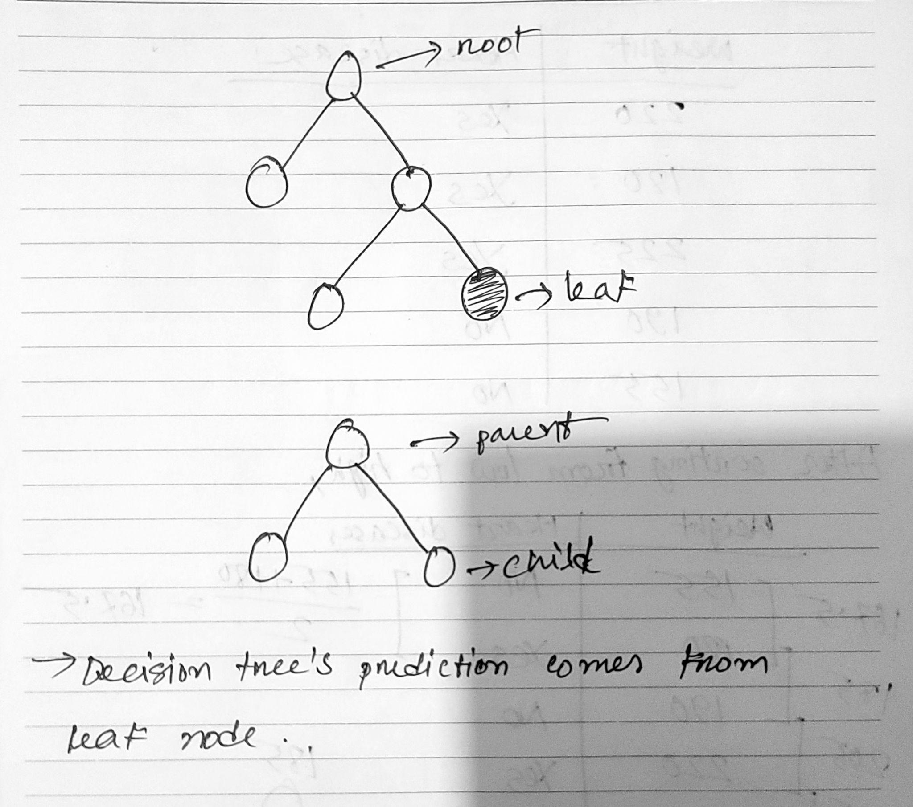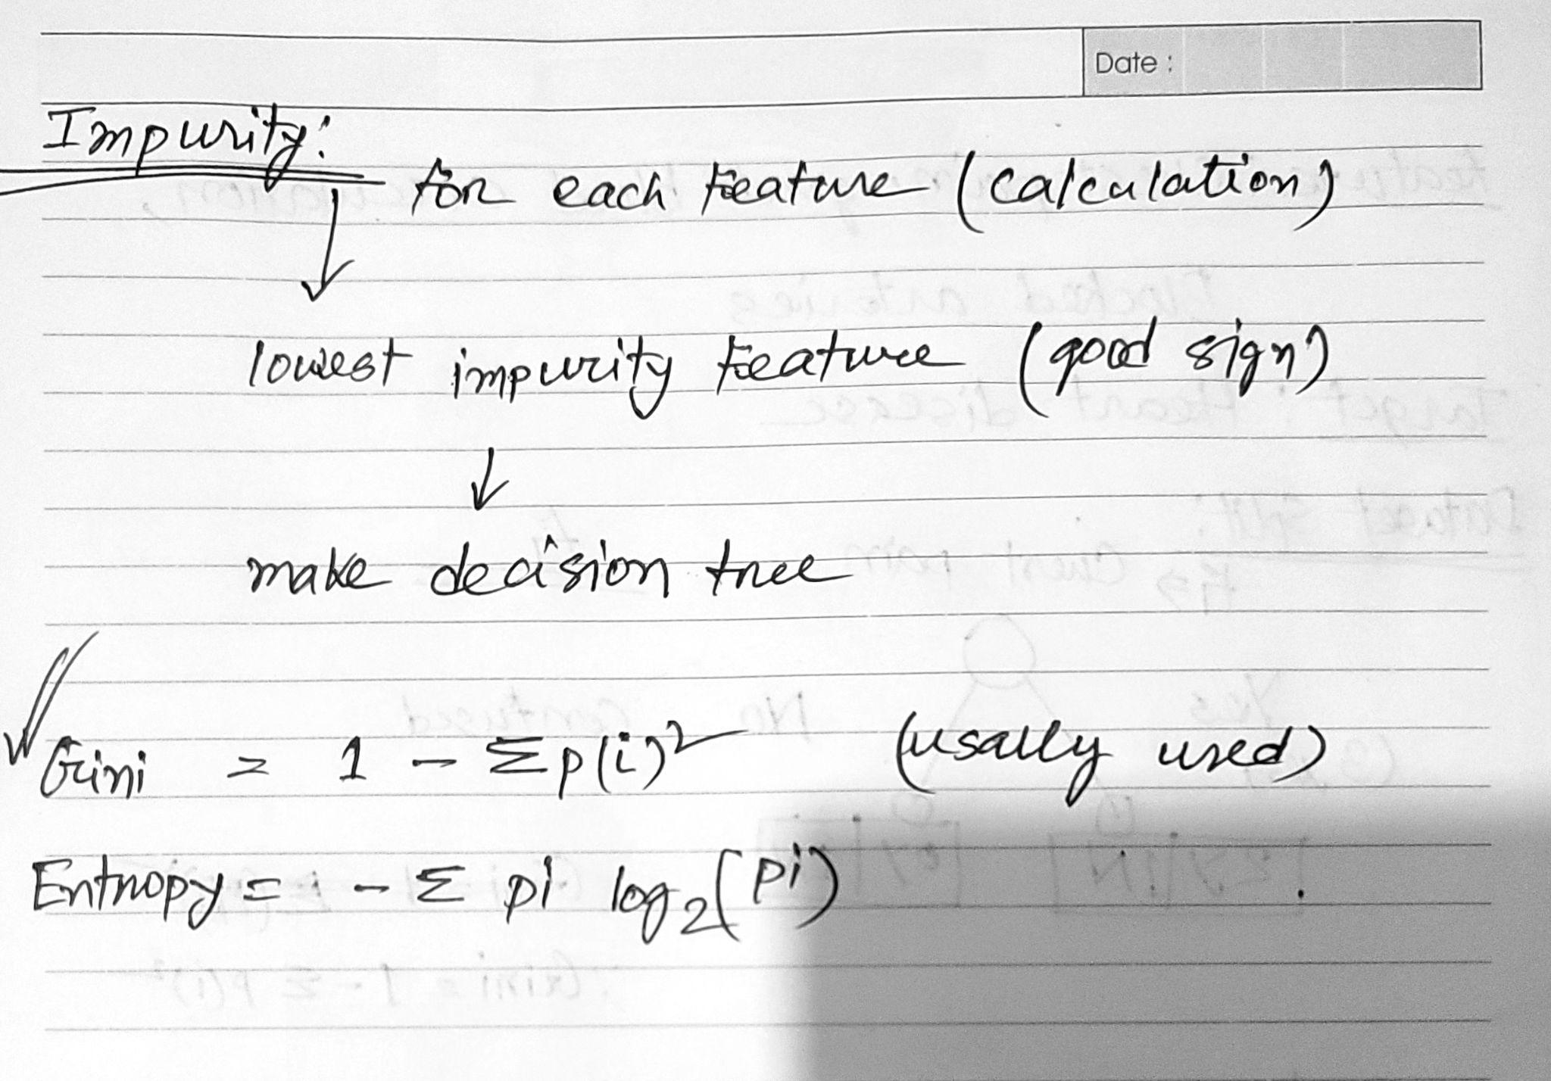

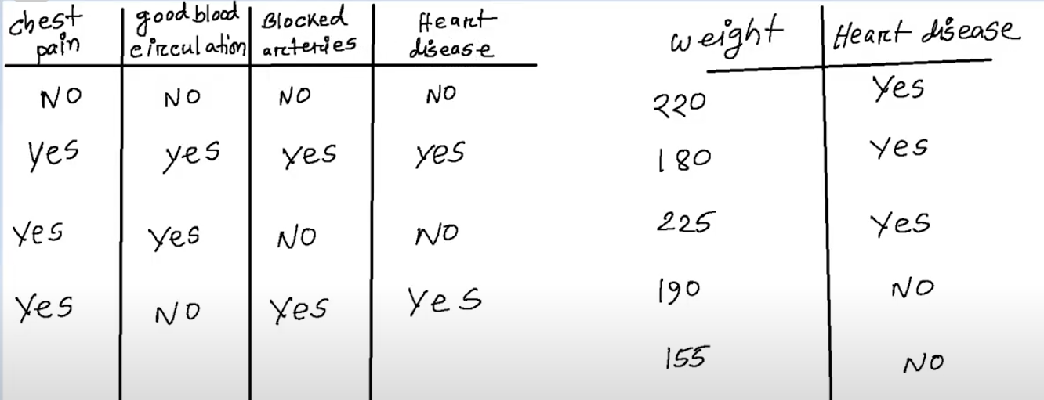

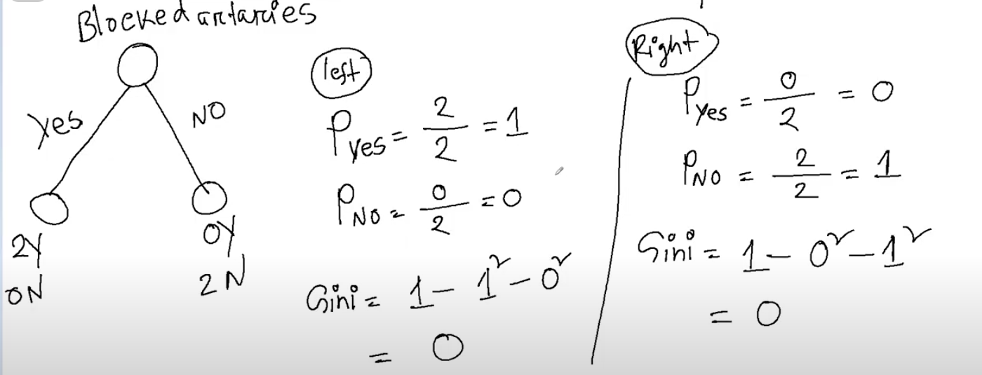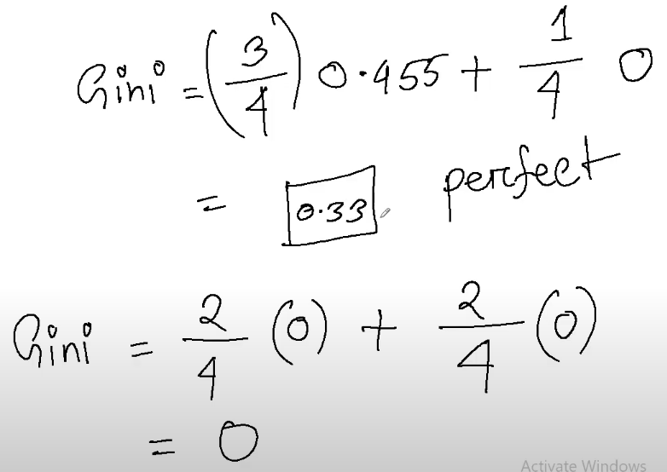

### 

### Decision based on Information Gain:

#### Decision Trees:

* Think of a decision tree like a flowchart, where each decision leads to more decisions, and finally, to an outcome. In each step, we make a decision based on certain features to get closer to our goal.

#### Entropy - Measure of Disorder:

* Entropic Playground: Entropy is like a measure of messiness or disorder in our data.
* Low Entropy: Low entropy means our data is more organized or homogeneous.
* High Entropy: High entropy means our data is a bit messy or diverse.

#### Information Gain - Seeking Order:

* Information Gain is our guide. It helps us decide which features bring more order to our data. We pick the feature that reduces the chaos in our dataset the most.

#### Classification or Regression:

Once the decision tree is built, it can be used for classification (for categorical target variables) or regression (for numerical target variables). Each path from the root to a leaf node represents a decision rule.



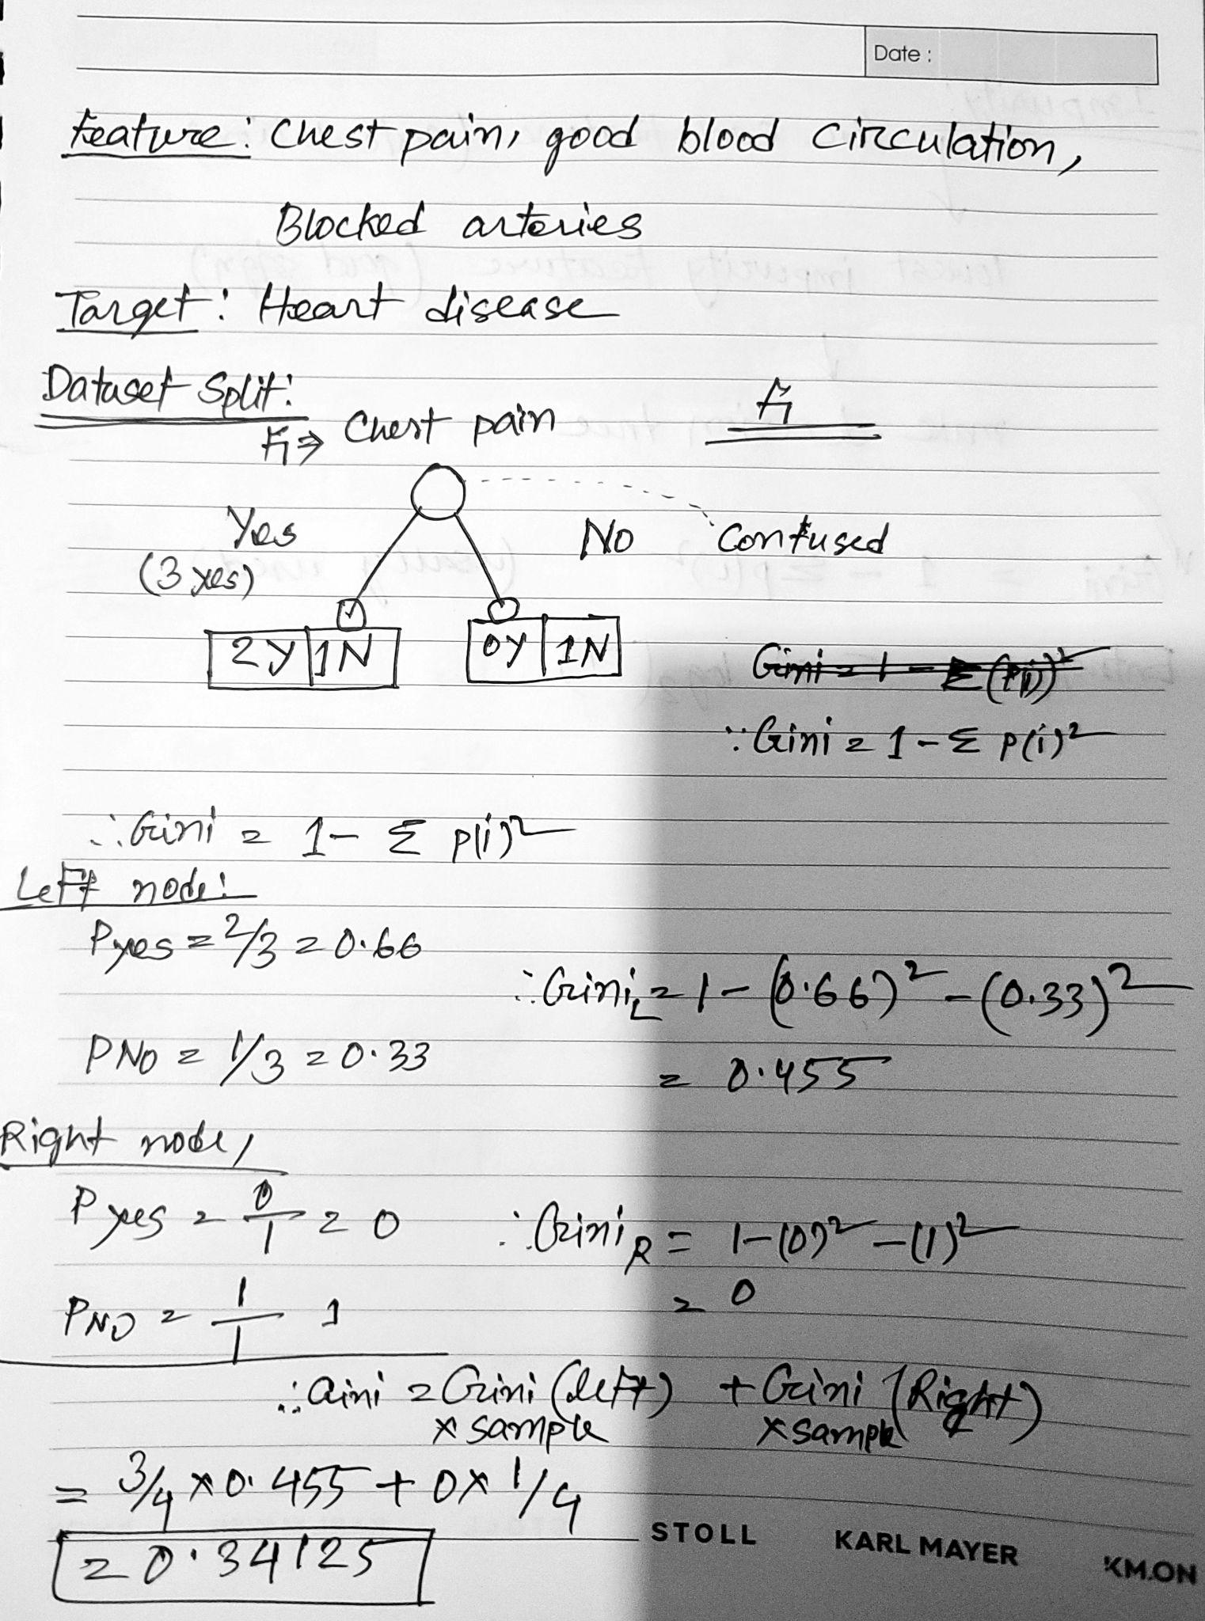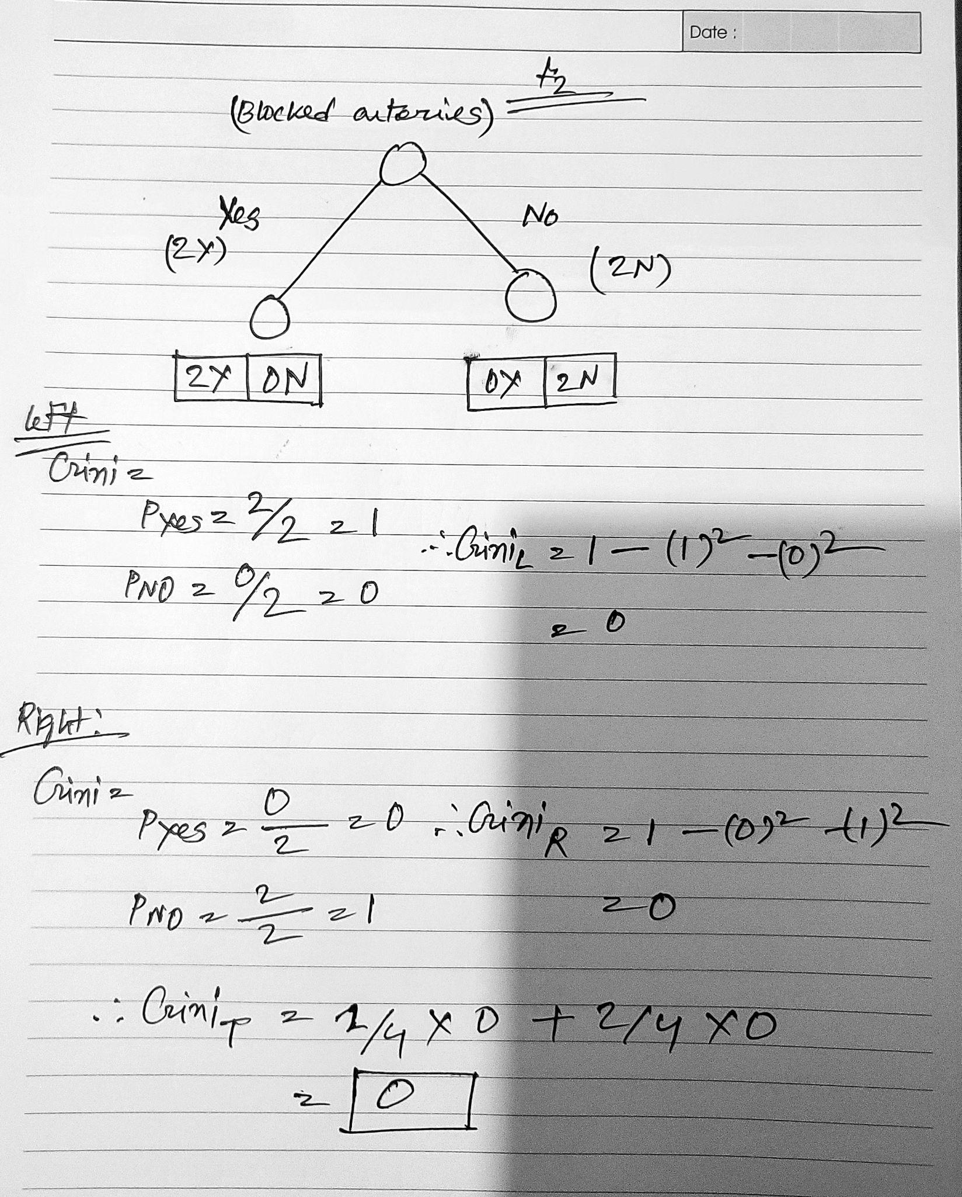

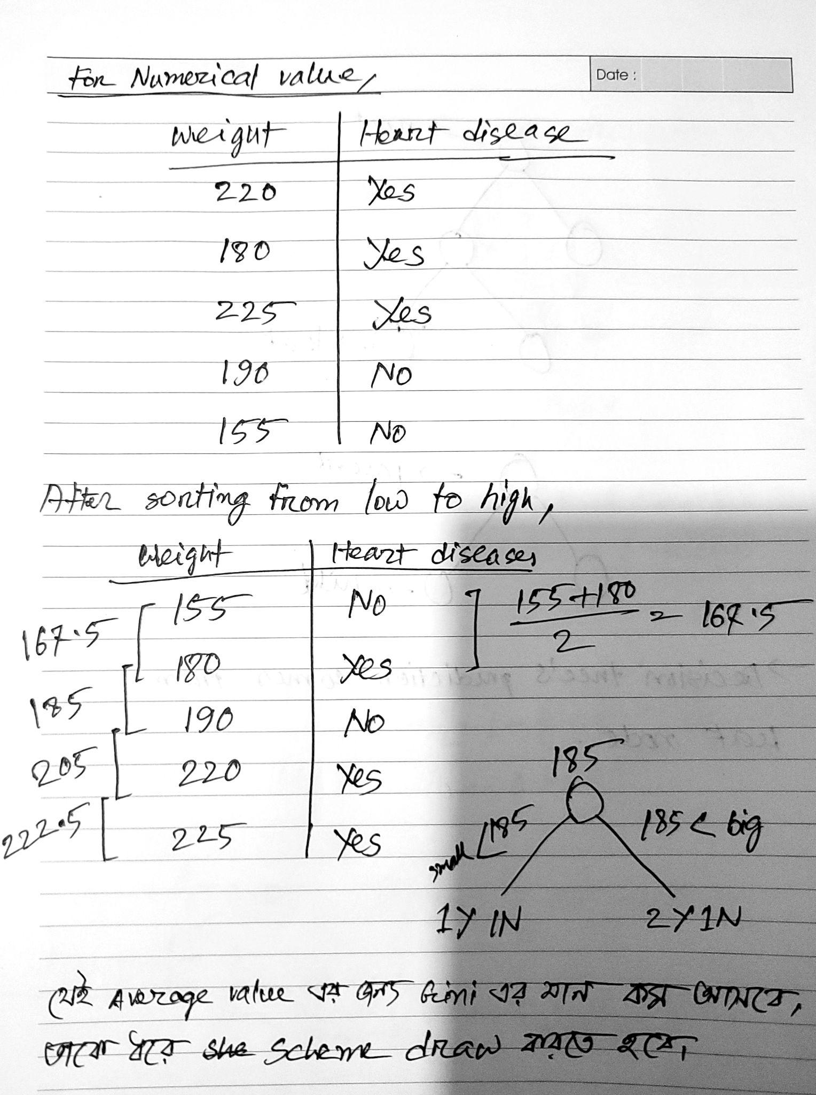

## Decision Tree Colab:

<https://colab.research.google.com/drive/1Kvm_faeSyZOfKop6WuSrQ_BTpChS2xrw?usp=sharing>

[3. SVM classifier, Decision Tree Regressor-Classification.ipynb](https://colab.research.google.com/drive/1Kvm_faeSyZOfKop6WuSrQ_BTpChS2xrw?usp=sharing)